International Civil Aviation Organization
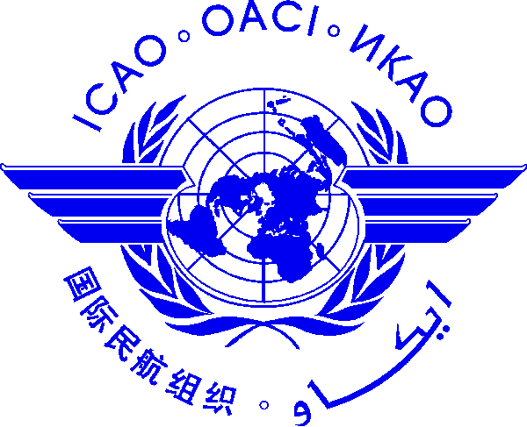 |  | Cooperative Development of Operational Safety and Continuing Airworthiness Programme (COSCAP)  Cabin Safety Seminar  19 to 21 November 2013  Singapore Aviation Academy - Singapore  Please register by: 8 November 2013

Nomination Form [please type or print]

State/ Organization
Name | Title |  | Family name (capitals) | First name | Middle initial
Mr.
Ms.
Official Position
Mailing Address
Telephone (office)
Fax
(office)
E-mail
Hotel in Singapore
Date

Note 1: Participants are expected to make their own hotel and visa arrangements.

After completing, please send to:
COSCAP-SEA Administrative Officer
E-mail: khun.nong@coscap-icao.org
Fax International: +66 2 287 0805

Copy to:
CAA Singapore
Ms. Ms. Dian Herdawaty
E-mail: dian_ahmad@caas.gov.sg
Fax International: +65 6543 2778

